**UNIT - IV**

***Introduction to Dimensionality Reduction (Simplified)***

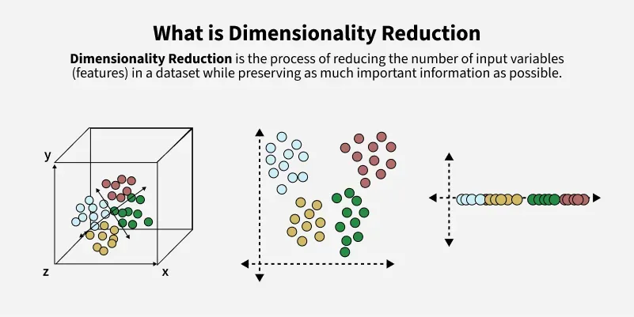**When working with machine learning, having too many features (columns) in your dataset can slow things down and cause problems like overfitting.  
Dimensionality reduction helps by reducing the number of features while keeping the most important information.**

**Simple Example:**

**Suppose you're predicting house prices using features like:**

* **Number of bedrooms**
* **Square footage**
* **Location**

**Now, if you add too many extra features like flooring type or room condition, the dataset becomes complex. Dimensionality reduction helps remove less useful features and focuses on what matters most.**

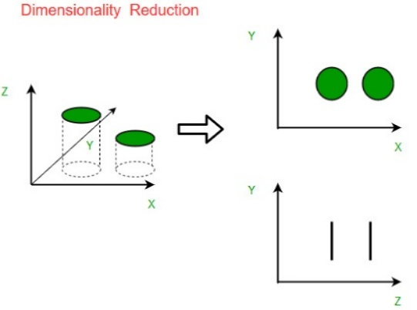**How It Works (Brief & Simple)**

**Imagine your data exists in 3D: X, Y, and Z axes.**

* **Before reduction: The data is in 3D, but most information is in X and Y. The Z-axis adds little value.**
* **After reduction: We drop Z and use just X and Y. The structure of the data is mostly preserved.**

**This makes the data easier to process, faster to analyze, and easier to visualize.**

**Types of Dimensionality Reduction**

**1. Feature Selection**

**This means choosing the best original features without changing them.**

* **Filter Methods: Use stats to pick features related to the target.**
* **Wrapper Methods: Try different feature combinations and choose the best.**
* **Embedded Methods: Select features during model training (e.g., Lasso regression).**

**2. Feature Extraction**

**This means creating new features by combining or transforming the original ones.**

**Some common techniques:**

1. **PCA (Principal Component Analysis): Combines features to form fewer "main" features with most info.**
2. **Missing Value Ratio: Remove features with too many missing values.**
3. **Backward Elimination: Start with all features, remove the least important one-by-one.**
4. **Forward Selection: Start with one feature, add more one at a time.**
5. **Random Forest: Uses tree models to find and rank important features.**
6. **Factor Analysis: Groups similar features and keeps the key ones.**
7. **ICA (Independent Component Analysis): Finds independent features—useful for separating mixed signals.**

**Real-World Examples**

1. **Text Categorization: Reduces words in large documents to classify them (e.g., spam or not).**
2. **Image Retrieval: Helps search for similar images using fewer visual features.**
3. **Gene Expression: Helps identify important genes in diseases (like cancer).**
4. **Cybersecurity: Detects intrusions by focusing on key activity patterns.**

**Advantages**

* **Faster Computation – Less data means quicker training and testing.**
* **Better Visualization – Easier to see data patterns in 2D or 3D.**
* **Prevents Overfitting – Fewer features = less chance of model memorizing the training data.**

**Disadvantages**

* **Loss of Information – Some useful data might be removed.**
* **Hard to Choose Components – Keeping too few or too many can harm model accuracy.**

Here’s a **simplified and easy-to-understand version** of your explanation on **Linear Discriminant Analysis (LDA)** in machine learning:

***🔍 What is Linear Discriminant Analysis (LDA)?***

**LDA** is a **supervised machine learning algorithm** used mainly for **classification and dimensionality reduction**.

It works by **finding a new axis (line or plane)** that best separates different classes in your data. It **projects** high-dimensional data into a lower-dimensional space while trying to **maximize class separation**.

**📊 Why Use LDA?** Lightbox

* To **reduce dimensionality** (fewer features)
* To **improve model accuracy**
* To **make data easier to visualize**
* Useful when classes overlap and are hard to separate using just one feature

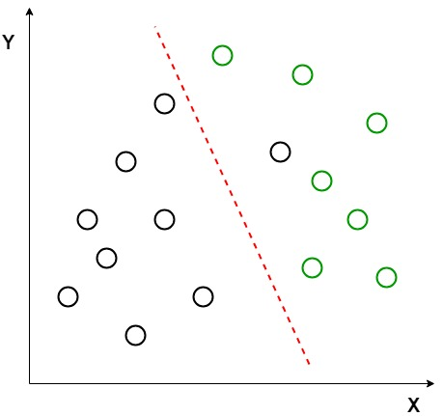**🧠 How LDA Works (in simple steps)**

1. **Assume** that the data in each class follows a **normal (Gaussian) distribution**.
2. **Calculate** the **mean** and **covariance** for each class.
3. **Find a new axis** that:
   * Increases the distance between class means.
   * Minimizes the spread within each class.
4. **Project the data** onto this new axis for better class separation.

📌 **Result:** After transformation, classes are easier to separate using a straight line.

**🎯 Key Assumptions of LDA**

| **Assumption** | **Meaning** |
| --- | --- |
| Gaussian Distribution | Each class follows a bell-shaped curve |
| Equal Covariance | All classes have the same spread structure |
| Linear Separability | Classes can be separated by a straight line or plane |

**💡 Example:**

Imagine two classes of data points (say, black and green dots) that are mixed together in a 2D space.  
LDA finds a **new line** (like a red dashed line) so that when we **project** the data onto that line, the classes are separated better.

**✏️ Mathematical Idea (Brief)**

* Let’s say you have two classes:
  + Class 1: mean = μ₁,
  + Class 2: mean = μ₂
* LDA finds a vector v (new direction/axis) that:
  + **Maximizes** the difference between projected means: |vᵗμ₁ − vᵗμ₂|
  + **Minimizes** the spread (scatter) within each class

🎯 **Goal**: Maximize the ratio:  
  **(distance between classes) / (spread within classes)**

This becomes an **eigenvalue problem**, and the direction v is the **eigenvector** that gives the best separation.

**🔄 Extensions of LDA**

| **Extension** | **Description** |
| --- | --- |
| **QDA (Quadratic Discriminant Analysis)** | Allows each class to have its own covariance (more flexible). |
| **FDA (Flexible Discriminant Analysis)** | Uses nonlinear functions to separate classes. |
| **RDA (Regularized Discriminant Analysis)** | Adds regularization to avoid overfitting. |

**🛠️ LDA Implementation with Python (Scikit-learn)**

from sklearn.datasets import load_iris

from sklearn.preprocessing import StandardScaler, LabelEncoder

from sklearn.discriminant_analysis import LinearDiscriminantAnalysis

from sklearn.model_selection import train_test_split

# Load data

data = load_iris()

X = data.data

y = data.target

# Standardize features

scaler = StandardScaler()

X_scaled = scaler.fit_transform(X)

# Split dataset

X_train, X_test, y_train, y_test = train_test_split(X_scaled, y, test_size=0.3)

# Apply LDA

lda = LinearDiscriminantAnalysis(n_components=2)

X_train_lda = lda.fit_transform(X_train, y_train)

X_test_lda = lda.transform(X_test)

**✅ What Each Step Does:**

* StandardScaler() – Makes sure all features are on the same scale.
* LabelEncoder() – Converts class labels to numbers (used if labels are strings).
* fit_transform() – Learns from training data and applies transformation.
* LinearDiscriminantAnalysis() – Learns the best axis to separate classes.
* transform() – Applies this learned axis to test data.

**✅ Summary**

* LDA reduces dimensionality **while preserving class separation**.
* It works well when data is **normally distributed** and classes have **equal variance**.
* It is simple, fast, and effective for **linear** class separation.
* **Doesn't work well** when classes are not linearly separable — use QDA or non-linear methods instead.

Here’s a **simplified and structured explanation** of **Principal Component Analysis (PCA)** for easy understanding, while keeping the key points brief but clear.

***📌 What is PCA?***

**PCA (Principal Component Analysis)** is a technique used to **reduce the number of features** (dimensions) in a dataset while **retaining the most important information**.

It transforms your original features into **new ones** (called **principal components**) that:

* Are **uncorrelated**
* Are ranked by **how much variation (information)** they capture

**🎯 Why Use PCA?**

* To make data **simpler and faster** to analyze
* To **remove redundant** features
* To **visualize** complex data in 2D or 3D
* To **improve model performance** by removing noise or irrelevant features

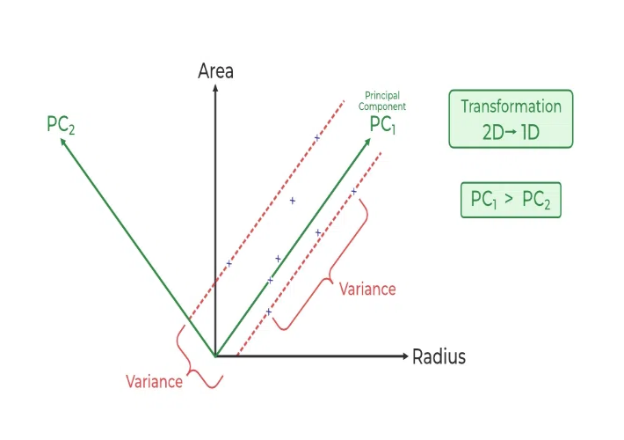**🔧 How PCA Works — Step by Step**

**Step 1: Standardize the Data**

* Different features (e.g., height vs. weight) have different units.
* PCA needs all features on the **same scale**.
* Standardization makes each feature have:
  + **Mean = 0**
  + **Standard deviation = 1**

**Step 2: Compute the Covariance Matrix**

* Shows how features vary together.
* Positive values: features increase together.
* Negative values: one increases while the other decreases.

**Step 3: Find Eigenvectors and Eigenvalues**

* **Eigenvectors** = new directions (principal components)
* **Eigenvalues** = importance of each direction
* The 1st component captures the **most variance**, then the 2nd, and so on.

**Step 4: Select Top Components and Transform**

* Keep only the **top k components** that explain most of the data (e.g., 95% variance).
* **Project the original data** onto these new axes (dimensions).

**🌌 Example – Visual Analogy**

Imagine a **cloud of stars** in space (your data points). PCA finds the best **viewing angles** (principal components) that show the shape of the cloud clearly in **fewer dimensions**.

**🧪 PCA in Python – Summary**

from sklearn.preprocessing import StandardScaler

from sklearn.decomposition import PCA

from sklearn.linear_model import LogisticRegression

from sklearn.metrics import confusion_matrix

import seaborn as sns

import matplotlib.pyplot as plt

# Standardize data

scaler = StandardScaler()

X_scaled = scaler.fit_transform(df.drop('Gender', axis=1))

y = df['Gender']

# Apply PCA

pca = PCA(n_components=2)

X_pca = pca.fit_transform(X_scaled)

# Train/test split and model training

X_train, X_test, y_train, y_test = train_test_split(X_pca, y, test_size=0.3, random_state=42)

model = LogisticRegression()

model.fit(X_train, y_train

# Predict and evaluate

y_pred = model.predict(X_test)

cm = confusion_matrix(y_test, y_pred)

sns.heatmap(cm, annot=True)

plt.show()

**✅ Advantages of PCA**

* **Reduces complexity** in high-dimensional datasets
* **Handles multicollinearity** (highly correlated features)
* **Speeds up processing**
* **Improves visualization**
* **Can help detect outliers**

**Disadvantages of PCA**

* **Hard to interpret** the new features (principal components)
* **Requires data scaling**
* **May lose information** if too few components are kept
* **Only works well with linear patterns**
* **Not ideal for very large datasets without optimization**

**📝 Conclusion**

PCA is a powerful tool to **simplify datasets**, **enhance model performance**, and **visualize patterns**—especially when working with many features. But it's important to **standardize your data**, choose components wisely, and be aware of **trade-offs like interpretability and potential info loss**.

Here’s a **clear and structured summary** of **Independent Component Analysis (ICA)** with a focus on core concepts, use cases, and practical implementation using Python:

***🎯 What is ICA?***

**Independent Component Analysis (ICA)** is a technique used to **separate mixed signals** into their **statistically independent** components.

It is often applied in:

* **Audio source separation** (e.g., the cocktail party problem)
* **Image processing**
* **EEG/ECG signal analysis**
* **Financial data analysis**

**🔍 Key Concepts**

**✅ Goal of ICA:**

Recover unknown **source signals** from observed **mixed signals** without prior knowledge about the mixing process.

**💡 Statistical Independence:**

Two signals are independent if:

P(XandY)=P(X)∗P(Y)P(X and Y) = P(X) * P(Y)

ICA finds components (features) that are **non-Gaussian and independent**, unlike PCA which finds **uncorrelated and orthogonal** directions.

**📐 Mathematical Formulation:**

* Let **X** be observed (mixed) signals → shape: (samples, n_mics)
* Let **S** be hidden (true) source signals
* ICA models:

X=A⋅S(Mixing)X = A \cdot S \quad \text{(Mixing)} S=W⋅X(Unmixing via ICA)S = W \cdot X \quad \text{(Unmixing via ICA)}

Where:

* **A** is an unknown **mixing matrix**
* **W** is the **unmixing matrix** ICA estimates

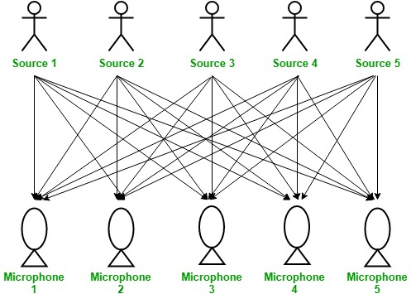**🗣️ Cocktail Party Problem**

Imagine:

* 3 people talking simultaneously (sources)
* 3 microphones placed around the room (observed signals)

Each mic captures a **mix** of all 3 voices. ICA helps separate the **original voices** from these recordings.

**🧪 ICA in Python using FastICA**

**Step 1: Import Libraries**

import numpy as np

from sklearn.decomposition import FastICA

import matplotlib.pyplot as plt

**Step 2: Create and Mix Signals**

np.random.seed(42)samples = 200

time = np.linspace(0, 8, samples)

# 3 original signals

signal_1 = np.sin(2 * time) # Sine wave

signal_2 = np.sign(np.sin(3 * time)) # Square wave

signal_3 = np.random.laplace(size=samples) # Random noise

# Combine and add Gaussian nose

S = np.c_[signal_1, signal_2, signal_3]

S += 0.2 * np.random.normal(size=S.shape)

# Mixing matrix (3x3)

A = np.array([[1, 1, 1], [0.5, 2, 1], [1.5, 1, 2]])

X = S.dot(A.T) # Mixed signals

**Step 3: Apply ICA**

ica = FastICA(n_components=3, random_state=0)

S_ = ica.fit_transform(X) # Estimated source signals

**Step 4: Plot Results**

plt.figure(figsize=(10, 8))

# Original Sources

plt.subplot(3, 1, 1)

plt.title("Original Source Signals")

for i in range(3):

plt.plot(S[:, i])

plt.tight_layout()

# Mixed Signals

plt.subplot(3, 1, 2)

plt.title("Mixed Signals")

for i in range(3):

plt.plot(X[:, i])

plt.tight_layout()

# Recovered Signals via ICA

plt.subplot(3, 1, 3)

plt.title("Signals Recovered Using ICA")

for i in range(3): plt.plot(S_[:, i])

plt.tight_layout()

plt.show()

**✅ Advantages of ICA**

* ✔️ Can recover independent sources even when they’re mixed linearly
* ✔️ Works well for **non-Gaussian** signals
* ✔️ Useful in **blind source separation**

**Limitations of ICA**

* Doesn’t work well if sources are **Gaussian**
* Requires number of sources ≤ number of observations (mics)
* Sensitive to **scaling and ordering**
* Assumes **linear mixing** only

**🤔 ICA vs PCA**

| **Feature** | **PCA** | **ICA** |
| --- | --- | --- |
| Goal | Maximize variance | Maximize statistical independence |
| Components | Orthogonal (uncorrelated) | Independent (non-Gaussian) |
| Output shape | Linear combinations | Independent source estimates |
| Use case | Dimensionality reduction | Source separation |

**📝 Summary**

* ICA is ideal for **separating independent signals** from mixed input.
* Unlike PCA, ICA focuses on **independence**, not just decorrelation.
* The **FastICA algorithm** is efficient and easy to use via scikit-learn.

Here's a **clear summary and walkthrough** of **Locally Linear Embedding (LLE)** — a powerful nonlinear dimensionality reduction technique — including its working, key concepts, parameters, and a full Python implementation.

***🧠 What is Locally Linear Embedding (LLE)?***

**Locally Linear Embedding (LLE)** is an **unsupervised nonlinear** technique used for **dimensionality reduction**. Unlike PCA, which is linear, LLE is capable of **“unfolding” complex, curved manifolds** (like a Swiss Roll) into lower dimensions while **preserving local relationships**.

**🔍 Core Idea**

LLE assumes that **each data point and its neighbors lie on a locally linear patch** of the manifold. It then:

1. Finds nearest neighbors.
2. Computes reconstruction weights.
3. Maps points to a lower-dimensional space that **preserves local structure**.

**✏️ Mathematical Formulation**

LLE tries to reconstruct each point from its neighbors:

Minimize: ∑i∣xi−∑jwijxj∣2\text{Minimize: } \sum_i \left| x_i - \sum_j w_{ij} x_j \right|^2

Subject to:

∑jwij=1\sum_j w_{ij} = 1

* xix_i: Original data point
* xjx_j: Neighbors of xix_i
* wijw_{ij}: Weights for reconstruction (sum to 1)

**⚙️ LLE Algorithm: Step-by-Step**

**1. Find Nearest Neighbors**

For each data point xix_i, find the **k-nearest neighbors** (Euclidean by default).

**2. Compute Reconstruction Weights**

For each point, compute weights wijw_{ij} to **linearly reconstruct** it from its neighbors with minimal error.

**3. Find Low-Dimensional Embedding**

Find new points yiy_i in lower-dimensional space that **preserve the reconstruction relationships**.

**4. Output**

The result is a **lower-dimensional dataset** that retains the **original neighborhood relationships**.

**🛠️ Key Parameters**

| **Parameter** | **Description** |
| --- | --- |
| n_neighbors | Number of neighbors to consider when reconstructing a point. |
| n_components | The desired number of dimensions in the reduced space. |
| method (optional) | Can use "standard" LLE, "modified", "hessian", or "ltsa" variations. |
| reg (optional) | Regularization to improve stability in near-singular systems. |
| eigen_solver | Specifies the solver used to compute the embedding (auto, dense, arpack). |

**📦 Python Implementation of LLE**

**Step 1: Import Libraries**

import numpy as np

import matplotlib.pyplot as plt

from sklearn.datasets import make_swiss_roll

from sklearn.manifold import LocallyLinearEmbedding

**Step 2: Generate Swiss Roll Dataset**

n_samples = 1000

n_neighbors = 10

# Swiss roll data (3D)

X, color = make_swiss_roll(n_samples=n_samples)

**Step 3: Apply Locally Linear Embedding**

lle = LocallyLinearEmbedding(n_neighbors=n_neighbors, n_components=2)

X_reduced = lle.fit_transform(X)

**Step 4: Visualize Original vs. Reduced Data**

plt.figure(figsize=(12, 6))

# Original 3D data

ax = plt.subplot(1, 2, 1, projection='3d')

ax.scatter(X[:, 0], X[:, 1], X[:, 2], c=color, cmap=plt.cm.Spectral)

ax.set_title("Original 3D Swiss Roll")

# Reduced 2D data

plt.subplot(1, 2, 2)

plt.scatter(X_reduced[:, 0], X_reduced[:, 1], c=color, cmap=plt.cm.Spectral)

plt.title("2D Embedding using LLE")

plt.tight_layout()

plt.show()

**✅ Advantages of LLE**

* ✔️ Captures **nonlinear structure**
* ✔️ **Preserves local geometry**
* ✔️ Good for **manifold learning** (e.g., unfolding Swiss roll)

**Limitations of LLE**

* **Sensitive to noise and outliers**
* Performance depends heavily on **choice of neighbors (k)**
* Doesn’t work well when local patches aren't truly linear
* Doesn’t generalize well to new data (non-parametric)

**🆚 LLE vs PCA vs t-SNE vs UMAP**

| **Method** | **Type** | **Nonlinear** | **Preserves** | **Handles New Data** | **Use Case** |
| --- | --- | --- | --- | --- | --- |
| PCA | Linear | No | Global variance | Yes | Simple datasets, compression |
| LLE | Nonlinear | Yes | Local structure | No | Unfolding manifolds |
| t-SNE | Nonlinear | Yes | Local clusters | No | Visualization, clustering |
| UMAP | Nonlinear | Yes | Local + Global | Yes | Visualization + ML pipelines |

**📝 Summary**

* **LLE** is a nonlinear method for reducing dimensions while preserving **local relationships**.
* It's ideal for **complex, curved data** (e.g., Swiss roll, face images).
* While powerful, it's **sensitive to parameters and noise**, and doesn't generalize.

Would you like:

* A notebook version of this code?
* A comparison plot of LLE vs PCA vs t-SNE?
* Real-world LLE applications?

Let me know how you'd like to explore further!